EYE TRACKING VIRTUAL MOUSE

Mr.Vishwesh Chavan Mr.Rushikesh Jadhav Mr.Shreyas Jadhav

B.E Final year B.E Final Year B.E Final Year

Pillai HOC College of Pillai HOC College Of Pillai HOC College Of

Engineering & Engineering & Engineering &

Technology Rasayani, Technology Rasayani, Technology Rasayani

Raigad,Maharashtra Raigad, Maharashtra Raigad,Maharashtra

vishweshpc20comp@stude rushikeshrj20comp@stude shreyassj20comp@stude

nt.mes.ac.in nt.mes.ac.in nt.mes.ac.in

# ABSTRACT

The primary characteristic of contemporary e-learning is the improvement of teaching methods through the application of cutting-edge, technologically-dependent products that promote student-teacher engagement and communication. allowing people with limited or no hand movement to independently operate a computer or mobile device. assisting those with disorders that interfere with utilizing and accessing technology, such as injuries to the spinal column and the disease amyotrophic lateral sclerosis.In this research, we suggest a hardware implementation of a virtual mouse that increases the real-time responsiveness of the existing "virtual mouse" over its current state.   
Keywords: Virtual Mouse, ALS.

# INTRODUCTION

The area of Human-Computer Interaction (HCI) is constantly evolving due to technical breakthroughs driven by the hunt for more natural and efficient methods to communicate with digital devices and interfaces. In the process, an eye-movement-controlled virtual mouse—a game-changing technology that completely disrupts traditional input methods—has emerged. In addition to redefining the parameters of human- computer interaction (HCI), this paradigm-shifting technology has the potential to completely transform how humans interact with computers by facilitating more inclusive, natural, and accessible interactions.

Eye-tracking technology has evolved quickly from being a specialised tool used only in research and specialised applications. What was originally thought to be a way to study visual attention has developed into an advanced interface that allows users to interact with virtual worlds, navigate digital landscapes, and operate hardware and software with the slightest movements of their gaze. By doing this, it broadens its application base beyond the domains of accessibility and assistive technology, finding use in virtual reality (VR), augmented reality (AR), gaming, and more.

With this concept, we can create virtual markers that perform mouse-like tasks by utilising expensive microcontrollers set up as Human Interface Devices (HIDs) for quicker interface response.

with an I2C interface-based infrared camera. The mouse pointer is moved to the position indicated by the coordinates when the IR camera infrared sources and transmits positional data, which Teensy converts to X and Y coordinates.

# LITERATURE SURVEY

Eye-tracking technology has its origins in the middle of the 20th century, mainly in the field of ophthalmology and psychology. The main purpose of the clunky early eye-tracking systems was to study visual attention and gaze behaviour. However, eye-tracking technology did not become a flexible HCI tool until the late 20th and early 21st centuries. Virtual mouse control and eye-tracking became widely used thanks to groundbreaking inventions like the Tobii EyeX and Eyegaze Edge.

* 1. **MOTIVATION**

There are many virtual markers on the market, but they are limited to using as markers. The data is processed by a high-level processor, which also serves as a virtual marker and is capable of performing additional tasks similar to those of a mouse. When a product's capabilities are not fully utilised, it becomes underloaded and ultimately more expensive when considering its function compared to its market price.

# PROPOSED SOLUTION

In this work, we provide an approach that maintains its capacity to create a virtual mouse, while simultaneously optimizing resource use and reducing the cost relative to its functionalities. Since a virtual mouse may be used as both a mouse and a virtual mouse, it is more helpful and compatible than a genuine mouse.

# WORKING PRINCIPLE

The following is the virtual mouse's algorithm:   
i. Recognition of objects.  
ii. Track the thing.   
iii Organize the computation.   
iv. Positioning the cursor.   
v. Creation of events.

1. There, we are making use of the smartphone's CV Camera. The initialization routine is used to initialize this camera. The camera is configured specifically for this particular use case II, meaning that it operates in Extended Mode.
2. The detector assembly interfaces an infrared sensor with the advanced processor via a two-wire interface based on the I2C protocol. Following that, Teensy is wired or wirelessly communicating with a laptop or PC.

*iii Object Identification:*

The 24MHz frequency that an infrared camera operates at can be produced with a Teensy or an external crystal. This camera can only identify infrared sources. As a result, it will detect the Virtual Mouse's infrared light.

1. *Track the object:*
2. We are developing this 24MHz clock.This clock can be utilized by the IR camera to sweep both axes. To pinpoint the precise position of the Infrared blob (Object), tracing the source entails skimming across the X and Y axes. The camera subsequently employs I2C communication to transfer this position data to a controller.

# Block Diagram:

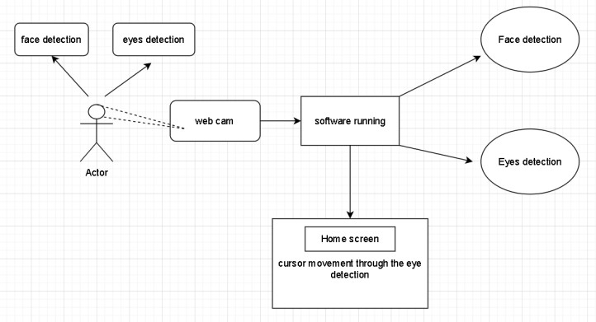 A basic structure of the virtualized mouse is shown in the first picture.A laptop is linked to a Teensy 3.1, which is interfaced with an infrared camera over I2C communication.

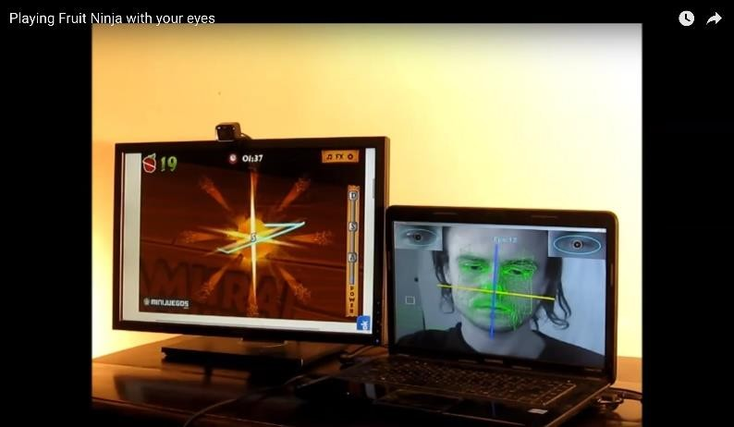

Figure 3: It takes a general configuration to implement the virtualized mouse

To perform the necessary mouse motions, the initial lecturer or tutor is going to have mouse in hand. The initial four clicks at the projector screen's edges define the Virtual Mouse's operational region. With each click, an infrared camera produces one coordinate. The process outlined below is used to compute the coordinates once the data has been collected.

1. *Calculation Of Coordinates:*

The coordinates of the conversion command is given as follows after the data has been acquired.   
[START state] [0xB1]  
For every coordinate position, it will provide three bytes of data, denoted by XX, YY, and SS. These coordinate values are used to calculate both X and Y co-ordinates, as shown by the following formulae.

1. *Setting cursor position:*

These calculations can be used to get the coordinate values.. The mouse cursor may be moved using a microcontroller equipped with a HID capability, as was previously mentioned. There is built-in HID capability in the Teensy library. The mouse cursor is set when the HID procedures obtain the coordinates for X and Y from the infrared camera as inputs. The mouse pointer is moved by these functions to the location given by the X and Y coordinates. To mimic mouse movements like left and right clicks, we may make use of the built-in library and mouse functions..

1. *Event generation*.

The motion of the mouse is tracked by the IR camera, which reflects the same motion on the projector, using the IR Led location as the coordinate. Teensy moves the mouse pointer to a new spot while the camera follows the virtual mouse's movements. In this manner, Teensy will mimic your mouse movements and follow the camera's lead, tracking the blob as long as you move the mouse. Because this technique runs at an average frequency of 24 MHz, the real succession of dots looks as a continuous line.

# 4. EXPERIMENTAL RESULTS

It takes precise coordinate marking to make Virtual Mouse work. For the Coordinate calculations.The following diverse tasks can be performed by the virtual mouse in our project is as following:  
1) Virtual mouse: To shoot adversaries in video games, we frequently have to utilize the mouse. Instead of really clicking the mouse, you can use a virtual mouse as a shooter to make virtual shots on the screen.

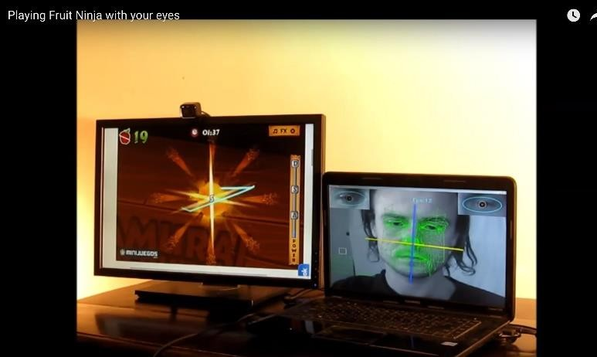

Virtual Mouse Using Laptop’s Web Cam

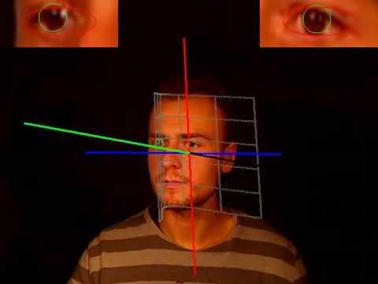2) Functions Of The Mouse : a person is able to click on the screen and the computer will correspond with their actions. The camera continuously records eye movements, as seen in Figure 8. This indicates that when we blink both eyes, virtual clicks are made and the left click function is triggered.

Figure 5: Click using Virtual Mouse

To click with the right mouseAn infrared camera tracks infrared light and provides the point's coordinates. The right click function will be completed when we only blink one eye.

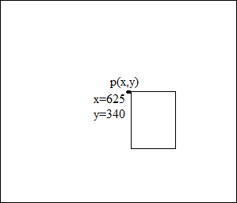Figure 6: Interpretation of Figure 9

Then, using the equations (1) and (2) from the coordinate calculation, actual co-ordinates are determined. After that, the library function will simulate a right click, launching a right click dialogue box.

# 5. CONCLUSION

To sum up, research into eye movements as a virtual mouse control method has revealed a technological marvel that goes beyond conventional Human-Computer Interaction (HCI) paradigms. The process of going through this literature review has shed light on the development, technological underpinnings, uses, and difficulties of this revolutionary technology, providing an understanding of its significant influence on accessibility, user experience, and other areas.

# REFERENCES:

1. Hacking the Nintendo Wii Remote, [www.computer.org/pervasive/](http://www.computer.org/pervasive/) lee2008.pdf
2. [http://procrastineering.blogspot.com/2008/09/working-with-](http://procrastineering.blogspot.com/2008/09/working-with-pixart-) [pixart-](http://procrastineering.blogspot.com/2008/09/working-with-pixart-)camera- directly.html
3. Teensy (ARM M4), https:/[/www.pjrc.com/teensy/](http://www.pjrc.com/teensy/)
4. Johnny Chung Lee, <http://www.wiimoteproject.com/>Johnny Chung Lee

- Projects - Wii.pdf

1. Soon Nyean Cheong, Wen Jiun Yap and Mun Leong Chan, “Cost- effective wiimote-based technology enhanced teaching and learning platform”, 2nd International Conference of Teaching and Learning (ICTL) INTI University College, Malaysia, 2009
2. Nintendo, Consolidated Financial Highlights, www.nintendo. co.jp/ir/pdf/2008/080124e.pdf, 24 Jan. 2008,
3. A Murgia1, R Wolff2, P M Sharkey1 and B Clark1, “Low-cost optical tracking for immersive collaboration in the CAVE using the Wii Remote”, Proc. 7th ICDVRAT with ArtAbilitation, Maia,

Portugal, pp 104-109, 2008

1. Andreas Holzinger, Selver Softic, Christian Stickel, Martin Ebner. “Nintendo Wii Remote Controller in for Higher Education: Development and Evaluation of a Demonstrator Kit for e- Teaching”, Graz University of Technology, Institute for Information Systems & Computer Media (IICM)